1

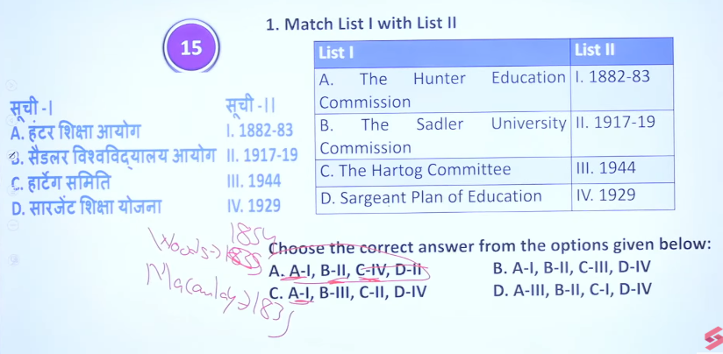

📚 Hunter Education Commission (1882)
👉 क्या किया?
- गाँव के बच्चों को पढ़ाना शुरू करवाया
👉 Easy line:
➡️ Hunter = Primary school (नीचे से शुरू)

🎓 Sadler University Commission (1917)
👉 क्या किया?
- पढ़ाई का पूरा सिस्टम बनाया (school → college → university)
👉 Easy line:
➡️ Sadler = Education system बनाना

📖 Hartog Committee (1929)
👉 क्या किया?
- बोला कम पढ़ाओ लेकिन अच्छा पढ़ाओ
👉 Easy line:
➡️ Hartog = Quality (अच्छी पढ़ाई)

🏫 Sargent Plan of Education (1944)
👉 क्या किया?
- सब बच्चों को free education देने का plan
👉 Easy line:
➡️ Sargent = सबको पढ़ाना (free education)

🔥 सबसे आसान Trick (1 सेकंड में याद करो):
- Hunter → Start (शुरुआत)
- Sadler → System (ढांचा)
- Hartog → Quality (अच्छा)
- Sargent → All (सबको)

📚 Hunter Education Commission (1882)
- Focus: Primary education for Indians
- Gave control to local bodies, promoted vernacular language
👉 One line: Primary education + decentralization

🎓 Sadler University Commission (1917–19)
- Focus: University reform + education structure
- Introduced 12-year schooling & intermediate stage
👉 One line: Modern education structure (school → college → university)

📖 Hartog Committee (1929)
- Focus: Quality over quantity
- Reduced dropouts & wastage, limited higher education
👉 One line: Improve quality, not expansion

🏫 Sargent Plan of Education (1944)
- Aim: Universal education system
- Free & compulsory education (6–14 years)
👉 One line: Plan for universal, free education in India

🔥 Ultra-Short Trick (for revision):
- Hunter → Primary + Local
- Sadler → Structure
- Hartog → Quality
- Sargent → Universal Education

📚 Hunter Education Commission (1882)
The Hunter Education Commission was appointed in 1882 by the British Government under the chairmanship of William Hunter.

🔑 Purpose
- To review the progress of education after Lord Macaulay’s policy (1835)
- To examine the development of primary and secondary education in India

📝 Key Recommendations
- Focus on Primary Education:
  - Primary education should be expanded among the masses
  - Responsibility given to local bodies (district boards, municipalities)
- Secondary Education:
  - Encouraged private enterprise in secondary schools
  - Government should gradually reduce direct control
- Medium of Instruction:
  - Primary education should be in vernacular languages
- Grants-in-Aid System:
  - Expansion of financial support to private schools
- Role of Government:
  - Government should act as a supervisor, not direct provider

⭐ Significance
- Marked the decentralization of education
- Strengthened primary education system
- Promoted Indian participation in education

👉 In one line:
The Hunter Commission (1882) emphasized primary education, local control, and private participation in India’s education system.
The Hunter Education Commission was mainly for Indians (Indian children), not for English children.
👉 In one line:
It focused on improving primary education for Indians, especially the masses, through vernacular languages and local administration.

📚 Sadler University Commission (1917–19)
The Sadler University Commission was set up in 1917 under the chairmanship of Michael Ernest Sadler to examine problems of University of Calcutta.

🔑 Main Focus
- Improvement of university education in India
- Studied issues from school level to university level

📝 Key Recommendations
- 12-Year Schooling:
  - School education should be 12 years before university
- Intermediate Colleges:
  - Introduced Intermediate (Class 11–12) as a separate stage
- University Role:
  - Universities should focus on teaching + research, not just exams
- Expansion of Universities:
  - Recommended setting up new universities like University of Dacca
- Women’s Education:
  - Encouraged development of female education

⭐ Significance
- Improved structure of modern education system (school → intermediate → university)
- Reduced burden on universities

👉 In one line:
Sadler Commission focused on reforming university education and introducing the modern education structure in India.
what ishartog commitee short
📚 Hartog Committee (1929) – Short Note
The Hartog Committee was appointed in 1929 under the chairmanship of Philip Hartog.

🔑 Main Focus
- To review the problems of education quality in India

📝 Key Recommendations
- Primary Education:
  - Focus on quality over quantity
  - Reduce wastage and dropout rates
- Secondary Education:
  - Should be limited and selective
  - Not everyone should go for higher education
- Higher Education:
  - Improve standards and quality, not just expansion
- Vocational Education:
  - Promote practical and job-oriented education

⭐ Significance
- Shifted focus from expansion to quality improvement
- Highlighted issues like dropouts and inefficiency

👉 In one line:
Hartog Committee emphasized quality education and reducing wastage in the system.
what is sargeant plan of education
📚 Sargent Plan of Education (1944) – Short Note
The Sargent Plan of Education was prepared in 1944 by the Central Advisory Board of Education, under John Sargent.

🔑 Main Aim
- To create a comprehensive national education system in India

📝 Key Features
- Free & Compulsory Education:
  - For children 6–14 years
- Pre-Primary Education:
  - For children 3–6 years
- High School System:
  - Divided into junior and senior stages
- University Education:
  - Limited admission to meritorious students
- Technical & Vocational Education:
  - Emphasis on skill-based learning
- Teacher Training:
  - Improvement in training and status of teachers

⭐ Significance
- First detailed plan for universal education in India
- Became the base for future education policies

👉 In one line:
The Sargent Plan (1944) aimed at free, compulsory, and well-structured education for all children in India.

2
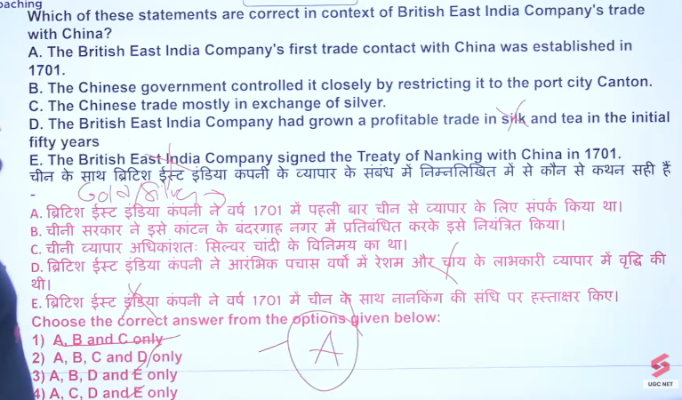

Birithis east india company ko gold and silver se trade me niksan tha isley baad me unhone opium se vypar karna start kyi tha angrejo ko gold and silver china bhejna patdat tho to trade profitalbel nhai tha uske jagha unhone opume bhejna start kyia tha
Jisko treaty of Nanjing bhe boteh ai
China ke sath tea ka trade krte the

📅 Time Period (Easy):
- Trade with China (Tea, Silk): 1700s–1800s
- Opium Trade begins: Late 18th century (around 1770s–1800s)
- First Opium War: 1839–1842
- Treaty of Nanking: 1842

👉 Super Short Answer:
➡️ 18th–19th century (mainly 1700s–1800s)

👉 Memory Trick:
“18th start → 19th war” 👍

🌏 British East India Company Trade with China

🔑 1. Main Objective
- To balance trade with China
- British wanted tea, silk, porcelain
👉 Problem:
- China did not want British goods → trade imbalance

💰 2. Trade Imbalance Problem
- Britain had to pay silver for Chinese goods
- Caused drain of silver from Britain/India

🌿 3. Solution: Opium Trade
- Company started growing opium in India (Bihar, Bengal)
- Sold opium illegally in China
👉 Result:
- China became addicted to opium
- Silver started flowing back to British

⚔️ 4. Conflict – Opium Wars
- Chinese government tried to stop opium trade
- Led to First Opium War
👉 Result:
- British victory
- Treaty of Nanking (1842)

📜 5. Treaty of Nanking (1842)
- China opened 5 ports for trade
- Gave Hong Kong to Britain
- Allowed British traders more rights

📦 6. Trade System (Earlier)
- Trade was restricted to Canton (Guangzhou)
- Known as Canton System

⭐ 7. Importance
- Helped British earn huge profit
- Strengthened British control over India & trade routes
- Weakened China economically & politically

🔥 Ultra-Short Revision Trick:
- Tea from China
- Opium from India
- War → Treaty → Control

👉 One Line:
British solved trade imbalance with China by selling opium from India, leading to Opium Wars and increased control over Chinese trade.
📜 Treaty of Nanking (1842) – Short Notes
👉 The Treaty of Nanking was signed in 1842 after the First Opium War between Britain and China.

🔑 Main Points (Easy)
- War End: Ended the First Opium War
- Ports Opened: China opened 5 ports (Canton, Shanghai, etc.) for British trade
- Hong Kong: Given to Britain
- Compensation: China paid war indemnity (money)
- Trade Rights: British got special trading rights

⭐ Why Important?
- First unequal treaty imposed on China
- Increased British control over Chinese trade
- Weakened China politically

👉 One Line:
Treaty of Nanking (1842) ended the Opium War and gave trade advantages + Hong Kong to Britain 👍

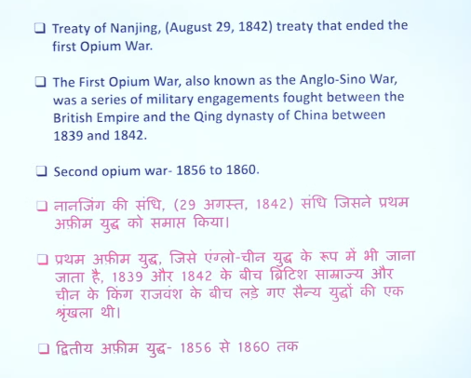

3
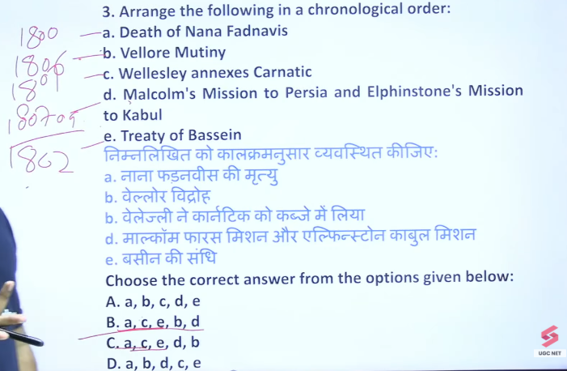

⚔️ Vellore Mutiny – Bilingual (Hindi + English Short Notes)

📅 When & Where / कब और कहाँ
- 1806, Vellore (Tamil Nadu)
- 1806, वेल्लोर (तमिलनाडु)

⚡ Causes / कारण
- Religious Interference:
  - New dress rules hurt religious beliefs
  - नई वर्दी के नियमों से धार्मिक भावनाएँ आहत हुईं
- Disrespect of Traditions:
  - British ignored Indian customs
  - अंग्रेजों ने भारतीय परंपराओं का सम्मान नहीं किया
- Tipu Sultan’s Family:
  - Sons of Tipu Sultan supported revolt
  - टीपू सुल्तान के पुत्रों का समर्थन मिला

🔥 What Happened / क्या हुआ
- Sepoys attacked British officers
- Soldiers captured Vellore fort briefly
- सिपाहियों ने अंग्रेज अधिकारियों पर हमला किया
- कुछ समय के लिए किले पर कब्जा कर लिया

❌ Result / परिणाम
- Revolt was crushed quickly
- Many soldiers were killed
- विद्रोह जल्दी दबा दिया गया
- कई सैनिक मारे गए

⭐ Importance / महत्व
- First major sepoy revolt before 1857
- Showed early resistance to British rule
- 1857 से पहले पहला बड़ा सैनिक विद्रोह
- अंग्रेजों के खिलाफ असंतोष का संकेत

👉 One Line / एक लाइन:
Vellore Mutiny (1806) was the first sepoy revolt due to religious interference
वेल्लोर विद्रोह (1806) धार्मिक हस्तक्षेप के कारण पहला सैनिक विद्रोह था 👍

4

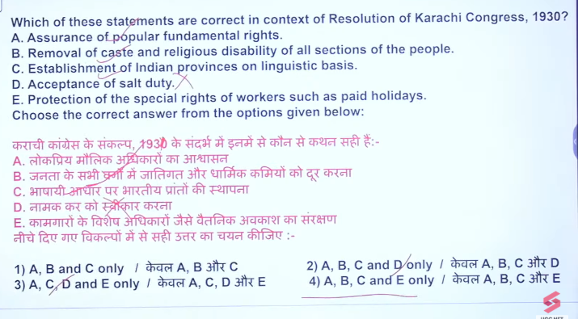

5
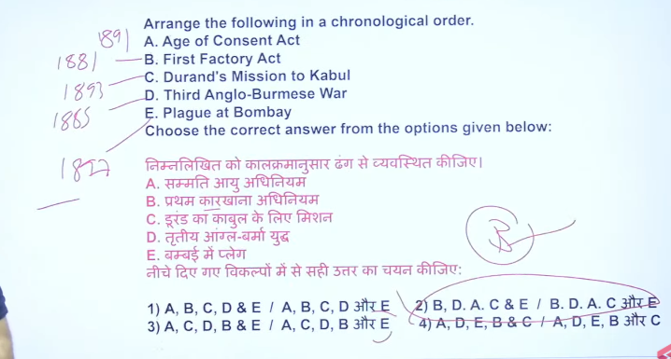

Age of consent 1860 me bhe hai aur 1891 me bhe hai
Plague at Bombay 1897
The Third Anglo-Burmese War took place from 7–29 November 1885.
The Bombay plague epidemic began in September 1896

6

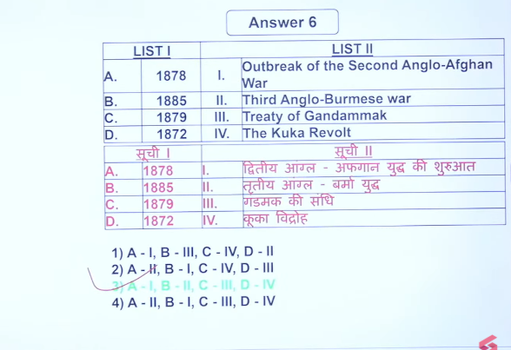

7
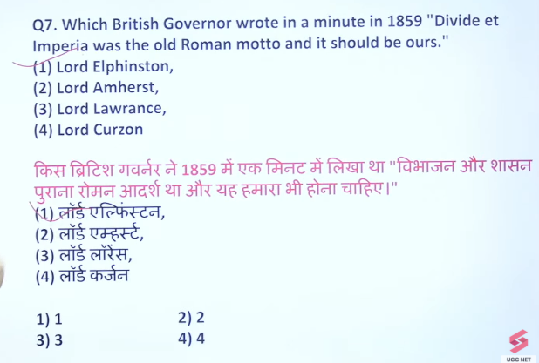
1857 ke Kranti ke baad peelcommission ata hai
1857 ke Kranti ke baad Bengal army me sare ke sare upper caste recrute kar dyia tha
Bengal region me avadh chetr ake andar jb unke bhawane lower caste ke hurt hue jb unke sentiment hurt hue theo peel vidroh hua
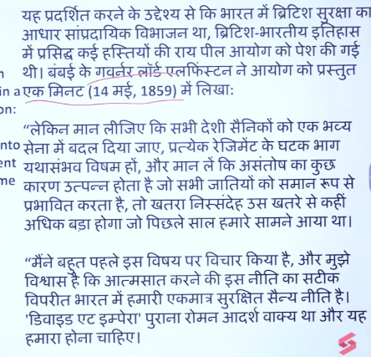

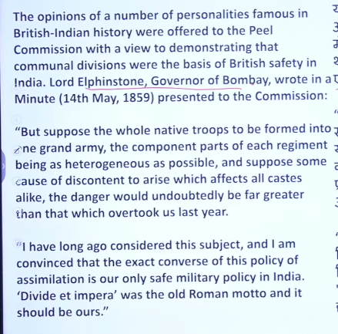

8
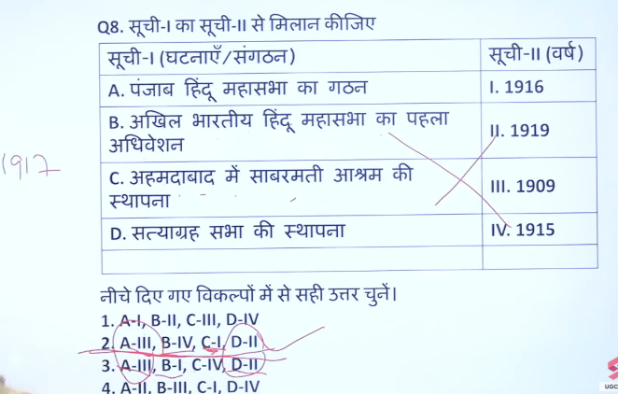
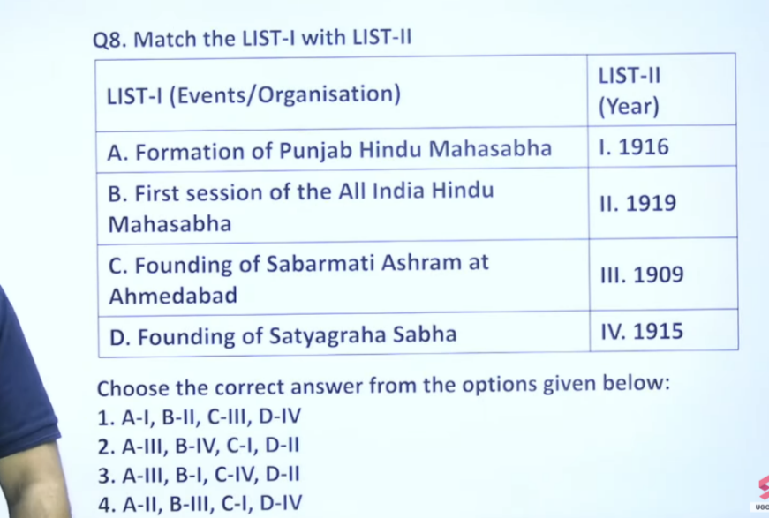s
Ahemdabad me Sabarmati ashram ke isthapan 1917 me hue the
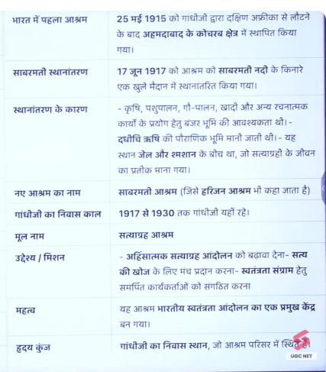
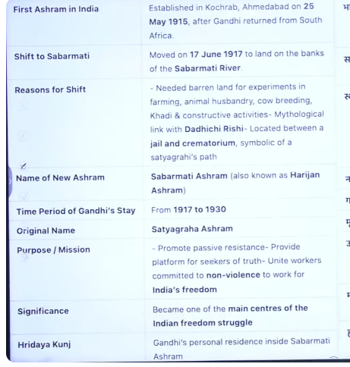

9
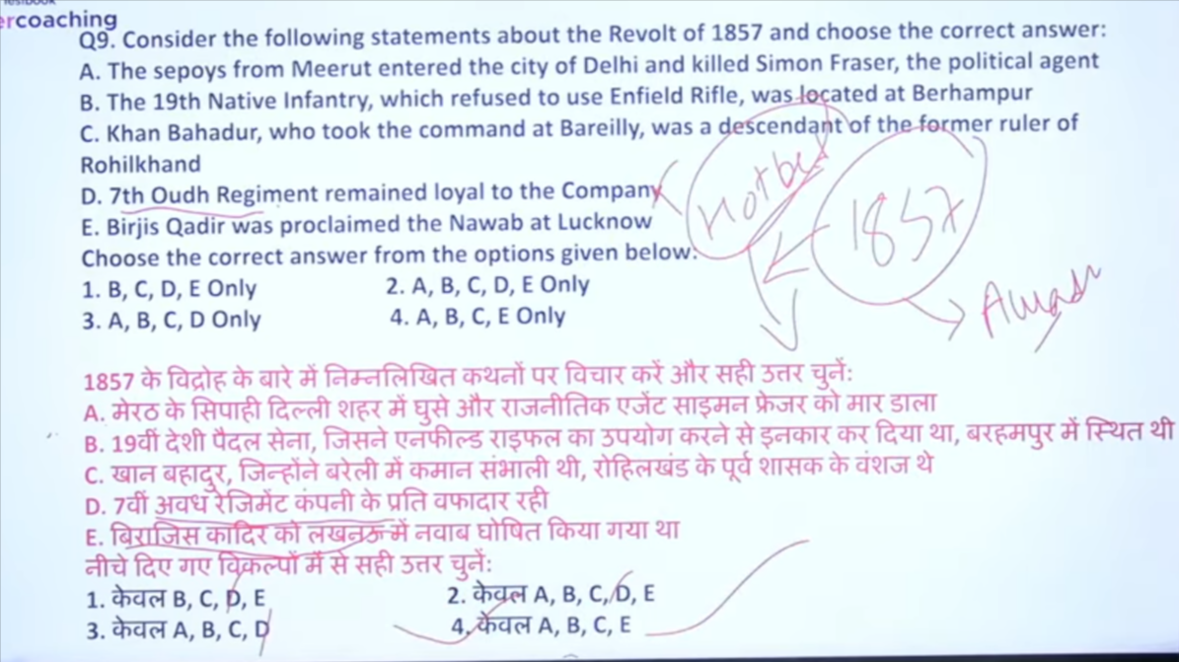

Ans is 4

d- 7th oudh regiment company ke vafadar the nahi jin logo ne vidrho kyia tha wo yahe log the 1857 ke andar hotbed of the revolt visfogt oudh ke andar he hua tha oudh ke andar kisne kyia tha to waha ke jo sainik the unhone he kyia ta to ye vafadar ku rahenge company k andar

10
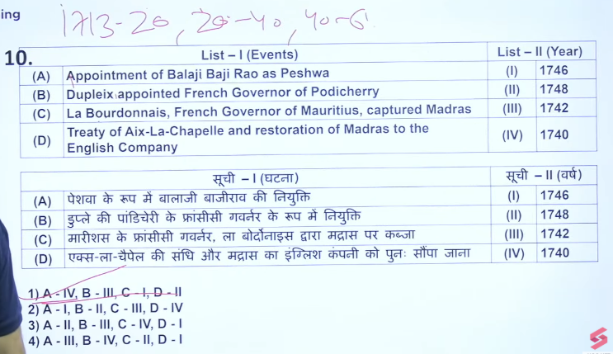
Shuru ke teen peshwa pahle peshw hogae 1713-20
Dusre 20-40 thesere 40-61
Balaji Viswanath hogae fir bajiraoo 1 hogae fir Balaji Bajirao 1 hogae

11
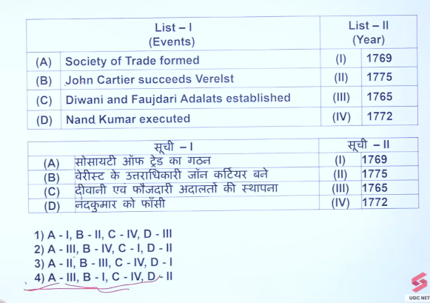

12
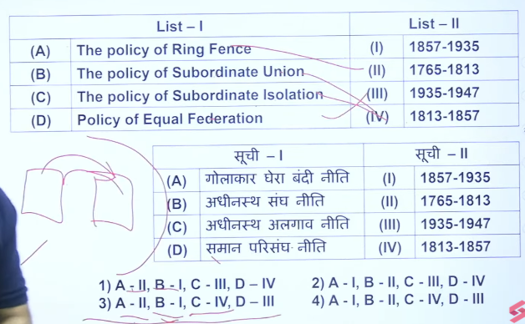

Nand kumar ko corruption ke charesges us time per wo indina ko bale ka bakra banan rhe the to corrumption ke charges me maharajah nand singh ko execuitive kar dyia gaya tha

13
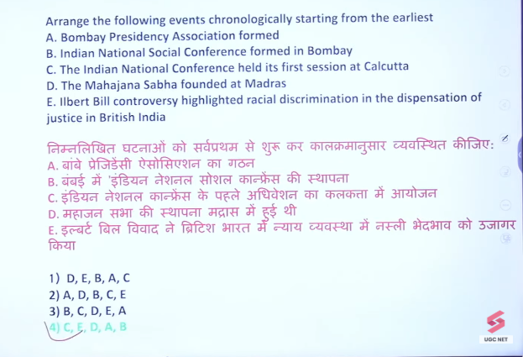
1883
1883
1884
1887
1885

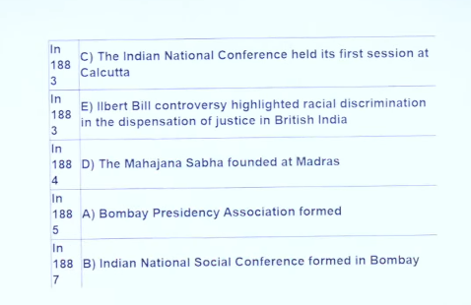\

Ec hona chaye kuki national conference ka pahla session December 1831 me hua tha

14

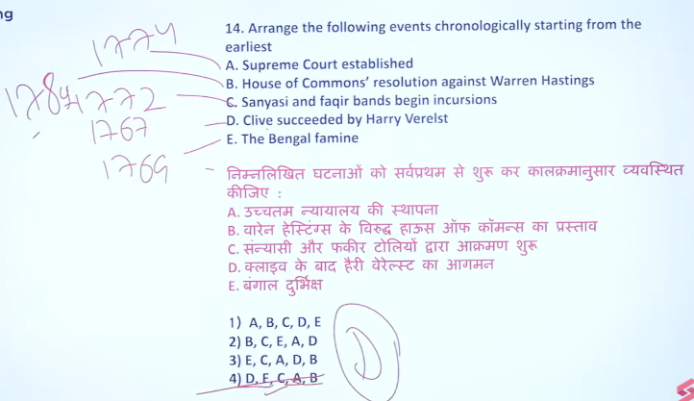
House of common 1780

15
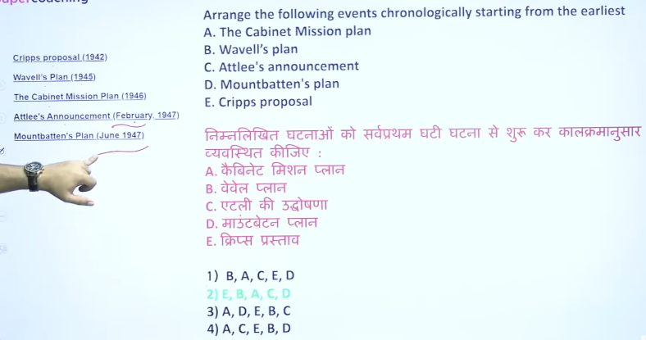

16
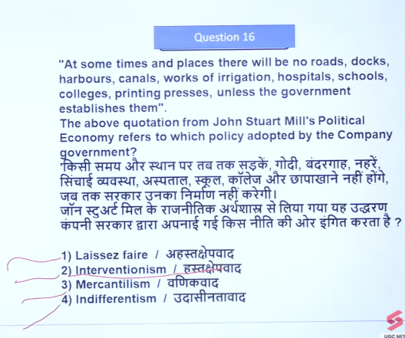

17

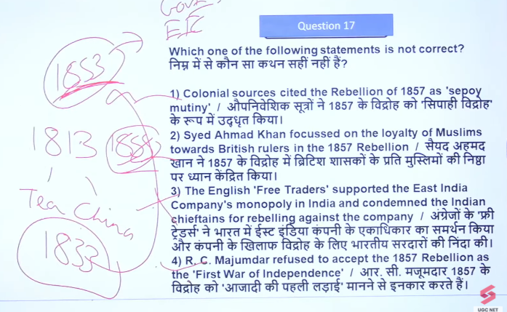

18

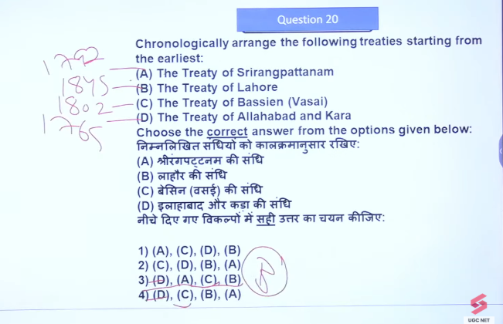

19
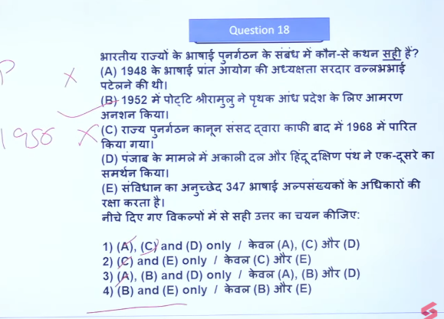

20
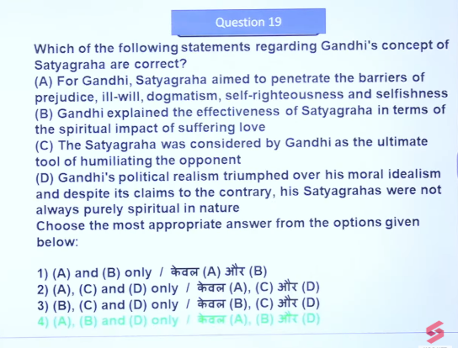
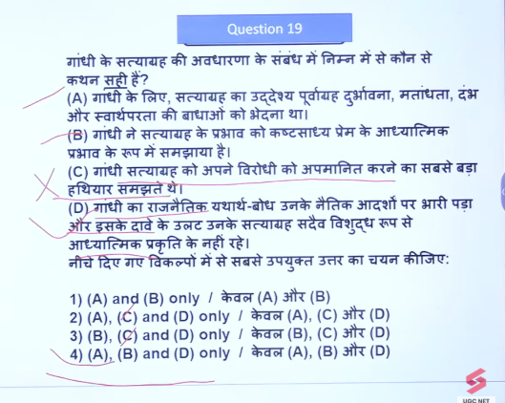

21

